**1. INTRODUCTION**

Hydraulic ram pump is widely used to provide energy for agriculture and domestic purposes. This type of pump is used by farmers and middle class people in rural areas for its zero running cost. It is a water pumping device that is powered by falling water which works by using the energy of water running down a drive pipe to the body of the ram pump. It pumps water from stream, creek and other water sources with flowing water. This device uses the kinetic energy of the falling water and it lifts it to the higher elevation than the source. Existing ram pumps have various limitations like complexity of usage, cost factor, maintenance etc. Therefore it is very much required to design a simpler system for the smooth usage. A hydram or impulse pump is an automatic pumping device which doesn't use electricity or any other power source. Hydram pumps the water to increases the water head which can be used in hydropower plants where high pressure water impinges on the turbine. It can have advantage of increasing the potential energy with a minimum set up and maintenance cost. Also it can tap energy at low velocity streams and the system can be affordable and scalable to Pico and micro hydropower systems. Various kinds and designs of hydrams were tried and the main challenges were the high noise from the waste valve, consistence wear on the waste valve rubber and corrosion problems. This research addresses these challenges by making uses of aluminium alloy and optimizing on the weights at the waste valve. A hydram is a structurally simple unit consisting of two moving parts. These are the impulse valve (or waste valve) and the delivery (check) valve. The system also consists of an air chamber and an air valve. The operation of hydram is alternating due to the cyclic opening and closing of the waste and delivery values. The closure of the waste valve creates a high pressure rise in the drive pipe. An air chamber is required to transform the high intermittent pumped flows into a continuous stream of flow. The air valves allow air into the hydram to replace the air absorbed by the water due to the high pressure and mixing in the air chamber.

**1.1. Working Principle**

Hydrams are designed to lift water (i.e. give potential energy to the water) from a low cost source of energy. Avoiding using fuel and electricity, the *water hammer effect* has shown to be efficient and is the principle of Hydrams.

The Hydram uses the water hammer effect to “use the energy of a large amount of water falling from a small height to lift a small amount of this water to a much greater height”.

From a source of water (i.e. spring or stream), the water is driven to the Hydram based downstream. The pump suddenly stops the flow causing a water hammer effect. It allows the water under pressure in the Hydram body to enter into a delivery pipe.

The special feature of the Hydram is that *the water hammer effect is caused by the water itself*. The flowing water applies pressure on a valve that closes the pipe automatically. This is why the Hydram does not use any electricity or fuel.

However, as the water hammer effect is caused by the water, the water needs to go out: this is called the *waste water*. This is not really wasted because the Hydram cannot work without it. So, the Hydram will use only 20 to 40 percent of the water coming inside it (i.e. the *feed water*): this is the *delivery water*.

A non-return valve at the beginning of the delivery pipe stops the water to go back into the pump body. After continuous water hammer effects, water is added in the delivery pipe with a great pressure. It allows the water to flow upward up to a storage tank.

The pressure is transform into potential energy.

**1.2. Water hammer effect**

The water hammer effect is a phenomenon that increases the pressure of water in a pipe over a short period of time.

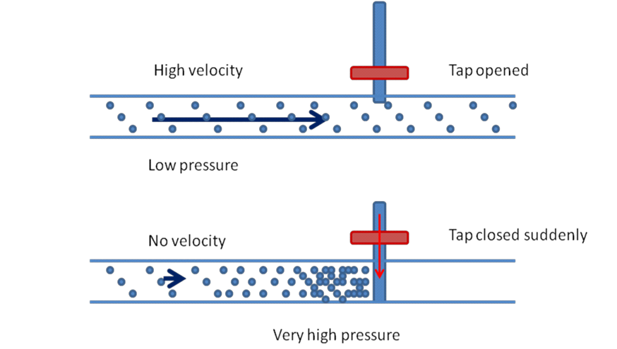

Fig 1 :- Water Hammer Effect

If the velocity of the water in a pipe is high enough, a fast closure of the pipe will cause a water hammer effect as shown in Figure. The water flowing will be compressed to the valve which has been closed suddenly.As a comparison, if a hundred people run very fast in a corridor and suddenly, they face a closed door, the space between them will be reduced, everybody will touch each other. In the same way, with velocity, water has kinetic energy. By closing quickly the pipe, this kinetic energy will be transformed into pressure.

This effect is characterized by a loud noise that is similar to a hammer banging a metal component.

**1.3. Application for the Hydraulic Ram Pump**

* It can be used for water supply to countryside and remote areas where a source having large quantity of water at some height is available and where the power is scarce so that the other types of pumps cannot be employed.
* Ram pumps can only be used in situations where falling water is available.
* Lifting drinking water from springs to settlements on higherground.
* Pumping drinking water from streams that have significant slope lifting irrigation water from streams or raised irrigation channels.

**1.4. Advantages of Hydraulic Ram Pump**

For any particular site, there are usually a number of potential water lifting options. Choosing between them involves consideration of many different factors. Ram pumps in certain conditions have many advantages over other forms of water-lifting, but in others, it can be completely inappropriate.

* Use of a renewable energy source ensuring low running cost
* Pumping only a small proportion of the available flow has little environmental impact
* Simplicity and reliability give a low maintenance requirement
* There is good potential for local manufacture in the rural villages
* Automatic, continuous operation requires no supervision or human input.
* Inexpensive
* Very simple construction and easy to install yourself.
* Does not consume petrol, diesel or electricity.
* Pollution free.
* Quiet pumping 24 hours per day.

**1.5. Disadvantages of Hydraulic Ram Pump**

* They are limited in hilly areas with a year-round water sources
* They pump only a small fraction of the available flow and therefore require source flows larger than actual water delivered.
* Can have a high capital cost in relation to other technologies
* Are limited to small-scale applications, usually up to 1KW, but this requires economical and other considerations.

**2. LITERATURE SURVEY:-**

1. Estimation of Power and Efficiency of Hydraulic Ram Pump(Authors:- Sampath S, Sawan Shetty, Allan Mathew Pendanathu, Waleed Javaid, Chithirai Pon Selvan) There are lots of limitations of conventional energy especially in the rural regions. Hence more attention of designers is diverted towards the use of unconventional energy. A mechanical device is designed works on the principle of conversion of potential energy to kinetic energy which is governed by gravity and runs on zero running cost. Present work involves in design and fabrication of hydraulic ram pump which is powered by the falling water from a small height to lift a part of that water required elevation. The current work emphasizes in the calculation of the discharge, power and the efficiency of the ram pump. The above is modified in terms of providing re-circulation system to avoid the wastage of water.
2. Designing of Hydraulic Ram Pump(Authors:- Rohan.D.Balgude, Swapnil.P.Rupanavar, Pradeep.S.Bagul ,Asst Prof. Manoday.R.Ramteke)This paper describes the techniques and guidelines to successfully install the modern hydraulic ram pump. The proposed technique illustrates the methodology that can be used for the primary design considerations and applications in various ways. This Hydraulic ram pump plays an important role in areas which are not connected to national electricity grid. This method provides means of continuous water supply. Basic principle of working is ramming action of air inside pressure vessel.
3. Hydraulic Ram Pumps(Author:- Gregory D. Jennings, PhD, PE) North Carolina Cooperative Extension Service Publication Number: EBAE 161-92 , Last Electronic Revision: March 1996 (JWM) A hydraulic ram (or water ram) pump is a simple, motorless device for pumping water at low flow rates. It uses the energy of flowing water to lift water from a stream, pond, or spring to an elevated storage tank or to a discharge point. It is suitable for use where small quantities of water are required and power supplies are limited, such as for household, garden, or livestock water supply. A hydraulic ram pump is useful where the water source flows constantly and the usable fall from the water source to the pump location is at least 3 feet.
4. . Design Methodology For Hydraulic RamPump (Hydram) (Seemin Sheikh, C C Handa and A P Ninawe) The availability and cost of electric power is a great concern to comman man. Conventional energy is also a great concern for environment. Hence more attention of designers is diverted towards use of unconventional energy or other forms of energy than onventionenergy. Water pump is a more utility item. The hydraulic ram pump is the mechanical pump which runs on kinetic energy of flowing water. Though the pump is in use since long, it is not seen in commanforms for lots of its performance limitations. This type of pump is a blessings to rural areas, farmers and middle class for its zero running cost. The paper after study the literature available aim to present generalised design methodology for hydraulic ram pump (HYDRAM) covering design parameters, design procedure along with the mathematical relationship used for the design work.

5. Analytical Calculations for The Hydraulic Ram Pump using Average Head Losses

(Piyush B. Shende , Dr. S. K. Choudhary, A. P. Ninawe) K.D.K.C.E Nagpur, India.

This paper presents the analytical calculations for the hydraulic ram pump using the average head losses. The study specifies that head losses includes while doing the sample calculations affects on the output results of the ram. These are based on a systematic study of hydraulic ram pump and testing of on hydraulic ramp pump model. For which we consider literatures reviews & some of them areused for the analytical calculations.

6.How to build a Hydraulic Ram Pump By Seth Johnson – Land To House™

Version 1.2 updated: 2/1/15 Steel- The hydraulic ram pump works because of a pressure wave that builds up and then passes. Two moving parts called one-way valves or check valves create this pressure wave. Water moves through a pipe known as a drive pipe to the pump system and flows out of the first check valve until the pressure reaches a value that causes the check valve to slam closeWhen the valve closes a small percentage of water is forced into the second check valve. A pressure tank located behind the second check valve forces the water out a pipe known as the delivery pipe. This pipe is what carries water to the desired destination.

7.Tom's Hydraulic Ram Pump (Tom Huppi) A 'hydraulic ram pump' is a device which uses the energy of falling water to propel a _portion_ of the water to a higher level. It doesn't need electricity, and it pumps at a modest rate which does not exceed the capacity of a small (inexpensive) pipe. These two criteria were exactly what I was looking for when I found out about the existance of such a solution.

8. Design and Analytical Calculation for a Hydram using Individual Head Losses

Author:-(Piyush shende, Dr.S.K.Chaudhari, A.P.Ninave)- This paper presents the design of hydram, basic concepts of hydram and analytical calculation using individual head losses of hydram with the related search. The study specifies individual head losses influencing the efficiency of the hydram. These are based on a systematic study of the all parameters affecting the hydram.

**3. COMPONENTS AND THEIR FUNCTIONS OF THE SYSTEM**

**3.1 The Hydraulic Ram Pump System**

**3.1.1 Objectives**

-Lift water from a source of water to a targeted community.

-Resist to internal fatigue due to the shocks of the water hammer effect.

-To reduce the use of non-renewable energy.

-To operate automatically and continuously with no external energy source.

**3.2. Supply tank**

**3.2.1. Objectives**

The header tank has five objectives:

* To prevent solid elements and air to enter in the Hydram;
* To allow a continuous flow in the Hydram;
* To allow the water to enter with a high velocity in the Hydram; and
* To resist to external aggressions;
* To allow the self-maintenance.

**3.2.2. Description**

In order to fulfill the uses of the supply tank, the design of the header tank depends on the characteristics of the water that flows in:

* Quality: impurities, sand, leaves, mud; and
* Quantity: flow available by the source of the water.

**3.3. Drive pipe**

**3.3.1. Objectives**

A drive pipe has two objectives:

* To allow the water entering in the pump body from the header tank with high velocity; and
* To resist to the shocks of the water hammer effect.

**3.3.2. Description**

A drive pipe is linked to only one pump. It can be made out of plastic ( pvc ) because it sustain the pressure. It is highly recommended to use first quality plastic pipes. Poor quality of plastic pipes will lead to difficult maintenance soon after the installation such as repairing leakage.

**10**

The efficiency of the pump increases if the components of the system do not absorbs the shocks of the water hammer effect.

Finally, the shock wave that goes along the drive pipe at each water hammer effect leads to a fatigue of the weakest part of the pipe: the threads at each end. This is a main cause of leakages.

The drive pipe must be made of a non-flexible material for maximum efficiency. This is usually PVC pipe, although other materials cased in concrete will work. In order to reduce head loss due to friction, the length of the pipe divided by the diameter of the pipe should be within the range of 150-1,000. Table 1 (in appendix) shows the minimum and maximum pipe lengths for various pipe sizes.

The drive pipe diameter is usually chosen based on the size of the ram and the manufacturer's recommendations as shown in Table 2 (in appendix). The length is four to six times the vertical fall.

**3.4. Pump basement**

**3.4.1. Functions**

The functions of the pump basement are:

* To hold the Hydram against the shocks of the water hammer effect; and
* To collect the waste water and to direct it to a targeted location to avoid having a muddy area around the pump and cavitations.

**3.5. Delivery pipe**

**3.5.1. Objectives**

* To supply water to delivery tank with required pressure.
* Minimized the distance and elevation to the storage tank to increase pumping rate.

**3.5.2. Description**

* Delivery pipe length is larger than supply pipe.
* Diameter of delivery pipe is small than suuply pipe because we have less quantity of water to lift than supply water.
* The delivery line can be made of flexible material .
* The delivery pipe can be of any material that can withstand the water pressure. The size of the line can be estimated using Table 4 (in appendix).

**3.6. Delivery water storage tank**

**3.6.1. Objectives**

* To store the water which is given from delievery pipe.

**3.6.2. Description**

Delivery tank height is greater than the supply tank.

**4. THE PUMP**

**4.1. Description of components**

**4.1.1. The pump body**

The pump body of a Hydram needs to be robust: it is the center of the water hammer effect.

The water enters from the drive pipe into the pump body and flows directly to the impulse valve.

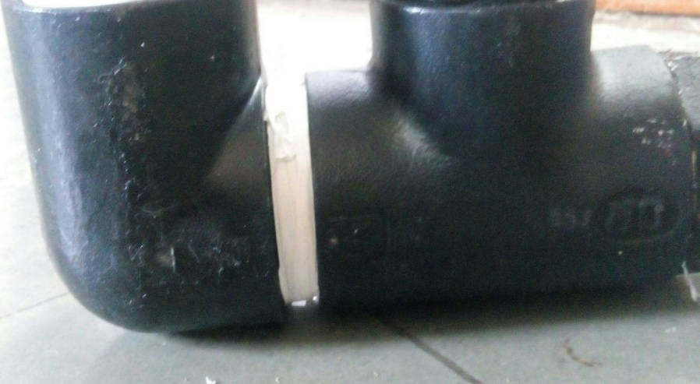

**FIG 2 .PUMP BODY**

**4.1.2. Impulse(Waste) valve**

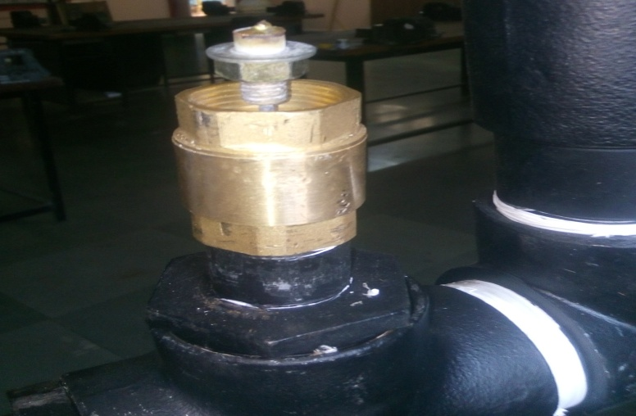

**Fig 3 :- Impulse valve and its components**

The impulse valve is located above the elbow of the pump body. The impulse valve is the part that allows the water to create continuous water hammer effects. The plug needs to be wide enough so that the water pushes it upward.

The closure needs to be fast and clear. This is why it is important to guide the plug vertically. Also, it is recommended that the contact surfaces between the plate and the plug are conical: this contact is better than flat surfaces for waterproof purposes.

The locking nut is used to stop the plug falling downward. It allows the modification of the length of the stroke of the plug. This option is better than putting simple nuts on the plug. One or two nuts are not enough: they get loose by the continuous hits when the plug goes down. This device makes sure that the length of the stroke stays the same until further modification during maintenance.

**4.1.3. Delivery valve**

The delivery valve is located above the tee of the pump body.

The delivery valve is a non-return valve: it allows the water to go from the pump body to the air vessel and forbid the water to flow in the opposite direction. When the pressure inside the pump body is higher than the pressure in the air vessel, the valve opens and let the water flows.

It may be a simple non return valve made up of stiff rubber or simple commercial check valve can work well.

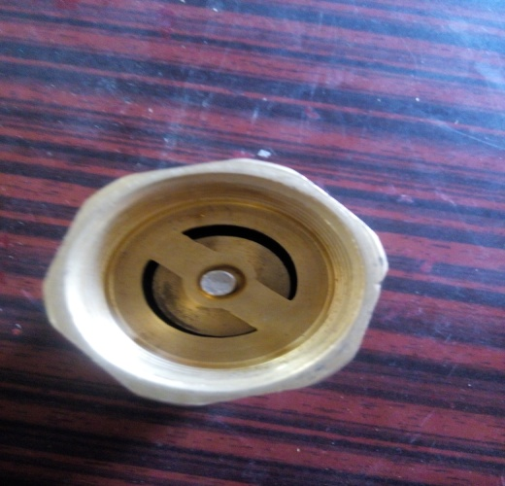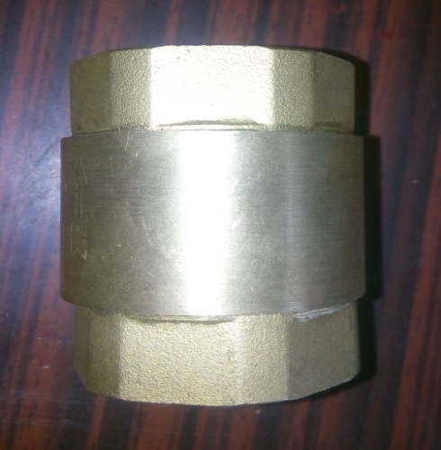

**Top view of delivery valve side view of delivery valve**

**Fig.4:- Delivery valve**

**4.1.4. Air vessel (Ram)**

The air vessel is located above the delivery valve.

The air vessel is a vital component of the Hydram and is visually its main

characteristic. Without it, the water coming through the delivery valve would have a great velocity and too much head losses would be created. With the air vessel, the air is slowed down because the air inside the air vessel acts like a spring. The air vessel improves a lot the efficiency of the pump.

If the air chamber becomes filled completely with water, the ram will pound savagely and may result in breakage; when this occurs, the ram must be stopped immediately. Some authorities suggest that the volume of the air chamber should be equal to water in the delivery pipe. On delivery pipe lengths, this would give an absurdly larger air chamber and a smaller size should be chosen.

In installing the ram, it is important that it be level, securely attached to an immovable base, preferably concrete, and that the waste-water be drained away. The pump can-not operate when submerged. Since the ram usually operates on a 24-hour basis the size can be determined for delivery over a 24-hour 0period. Table 3 (appendix) shows hydraulic ram capacities for one manufacturer's Hydrams.

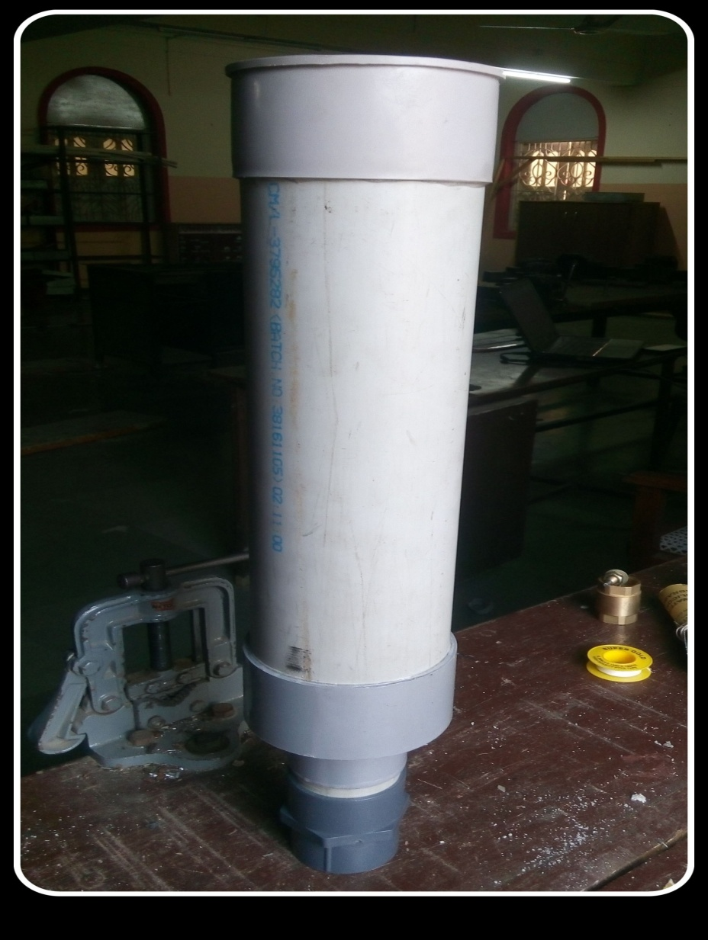

Fig.5:- Air Vessel

**5. METHODOLOGY**

**5.1 Working of Hydraulic Ram Pump**

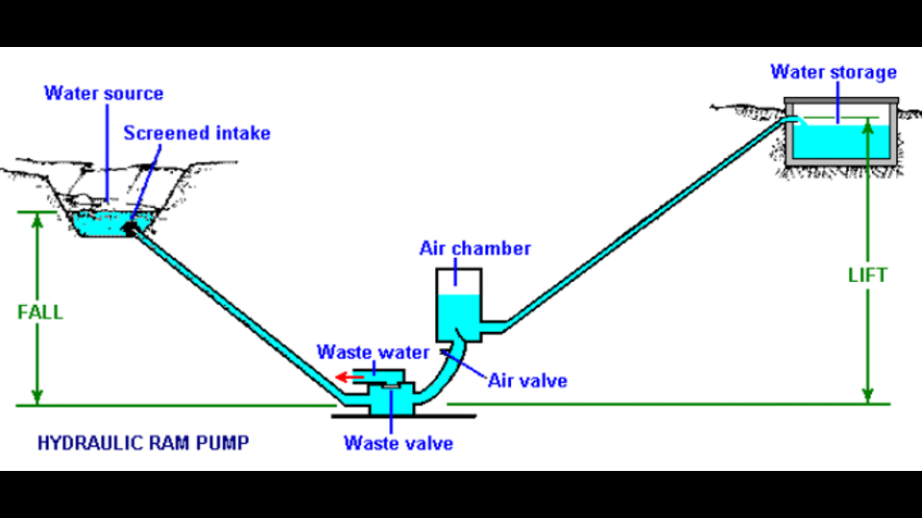

**Fig.6:- Working of Hydraulic Ram Pump**

**Operation 1:**

Water from the source flow through the drive pipe (A) into the ram pump body, fills it and begins to exit through the waste or “impulse” valve (B). The check valve (C) remains in its normal closed positions by both the attached spring and water pressure in the tank (D) and the delivery pipe (E) (no water in the tank prior to start up). At this starting point there is no pressure in tank (D) and no water is being delivered through exit pipe (E) to the holding tank destination (see Figure 1).

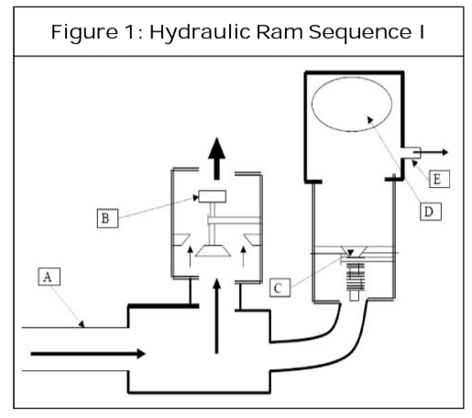

**Fig.7:- Hydraulic Ram Sequence 1**

**Operation 2:**

Water is entering the pump through the Drive Pipe (A). The velocity and pressure of this column of water is being directed out the Waste Valve (B) which is overcome, causing it to close suddenly. This creates a momentary high pressure “water hammer” that in turn forces the Check Valve (C) to open allowing a high pressure “pulse” of water to enter the Pressure Tank (D). The air volume in the pressure tank is compressed causing water to begin flowing out of the Delivery Pipe (E) and at the same time closing the Check Valve (C) not allowing the water a path back into the pump body. As the air volume in the Pressure Tank (D) continues to re-expand, water is forced out of the Delivery Pipe (E) to the holding tank in (figure.2).

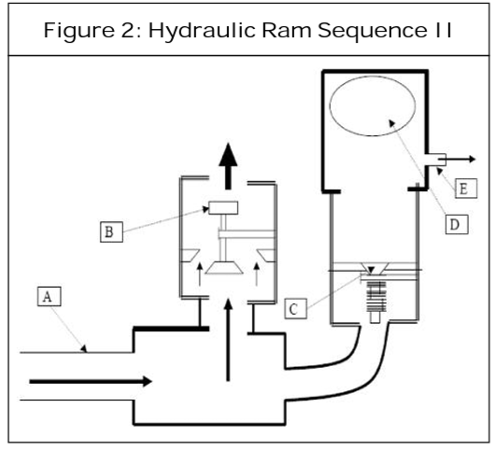 **Fig.8:- Hydraulic Ram Sequence 2**

**Operation 3**

Water has stopped flowing through the drive pipe (A) as a “shock wave” created by the“water hammer” travels back up the drivepipe to the settling tank. The waste valve (B) is closed. Air volume in the pressure tank (D) continues expanding toequalize pressure, pushing a small amount of water out of the delivery pipe (E). See the illustration in Figure 3.

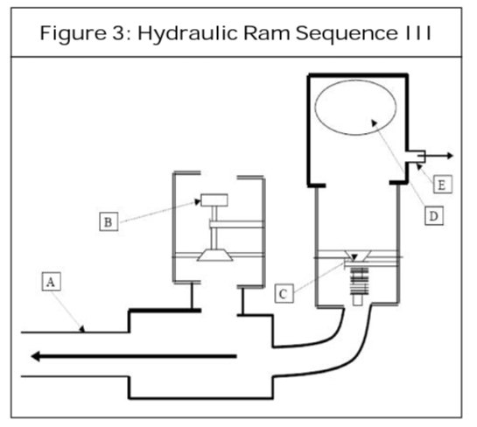  **Fig.9:- Hydraulic Ram Sequence 3**

**Operation 4**

The shock wave reaches the holding tank causing a “gasp” for water in the drive pipe (A). The waste valve (B) opens and the water in the drive pipe (A) flows into the pump and out of the waste valve (B). The check valve (C) remains closed until the air volume in the pressure tank (D) has stabilized and water has stopped flowing out of the delivery pipe (E). At this point sequence 1 begins all over again.(in Figure 4)

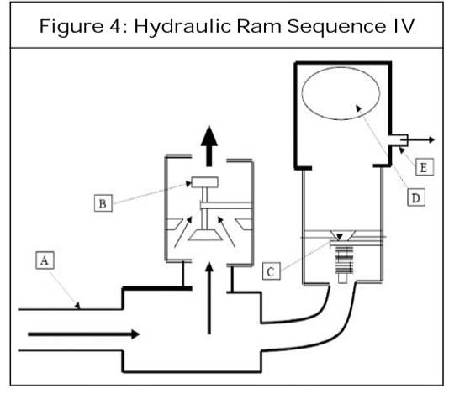 **Fig.10:- Hydraulic Ram Sequence 4**

**5.2 Fabrication of Hydraulic Ram Pump**

**5.2.1. Material required**

**Air Chamber Parts Schedule 40 PVC:**

1. 4''*18'' scheduled 160 PVC pipe
2. 4'' PVC pipe cap (Rounded high pressure, not waste grade)
3. 4'' to 2'' pipe PVC pipe reducer
4. 2'' PVC FTA
5. 12” Wheel Barrow Inner Tube.

**Pump Body Parts:**

1. 2''*21/2''nipple
2. 2'' 'T' female
3. 2'' close nipple
4. 1'' waste valve
5. 1'' check valve
6. 2'' street elbow
7. 1'' street elobow
8. 2''*1'' bushing
9. 1'' close nipple
10. 2''*3/4'' bushing
11. 3/4'' metal tee (female)
12. 1.5''PVC union with thread
13. 1.5'' ball valve
14. 3/4''ball valve(with threads)
15. 3/4'' PVC Union (with threads)
16. 1/4'' pipe cock
17. 1/4'' nipple
18. 3/4'' close nipple
19. 3/4''*2'' nipple
20. 3/4'' nozzle
21. 1.5'' close nipple
22. 1.5'' nozzle
23. 3/4''*1/4'' bushing

**Impetus / Waste Valve Conversion Parts:**

1. Stainless Steel Bolt
2. Stainless Steel Nut, & Washers (valve weights)
3. Faucet Washer

**Construction Material:**

1. Fiberglass resin and hardener
2. 100 grit sandpaper
3. PVC primer and cement
4. Black paint (spray and liquid rust hardening)
5. Teflon
6. M-ceil

**5.2.2. Fabrication Procedure**

1. First we arranged all components sequence wise on table.

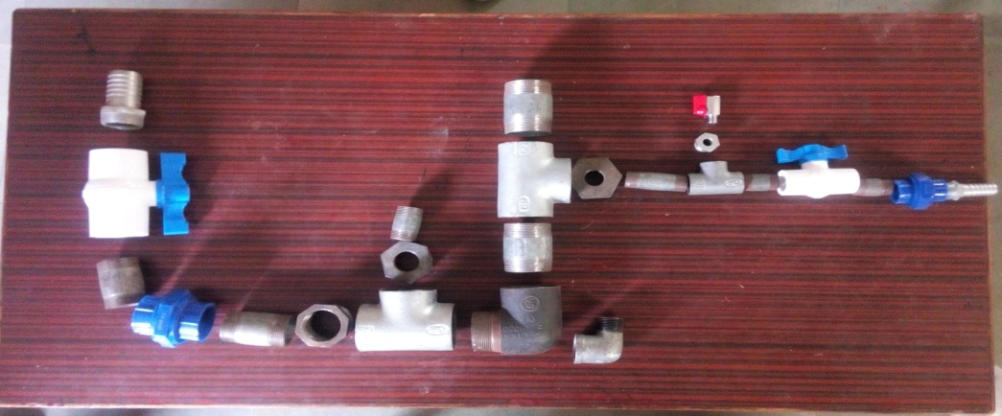

1. Then we do teflon coating on metal components which have external threaded.

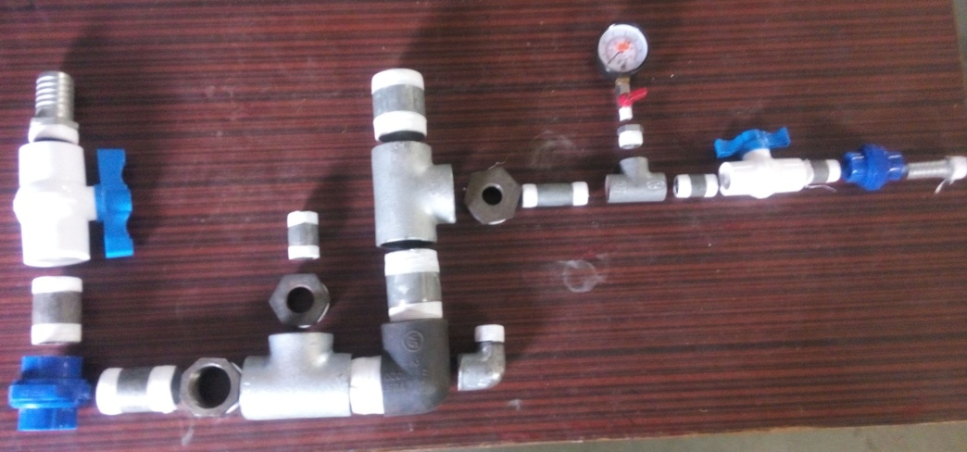

1. We place 1'' street elbow in 2'' elbow centrally align and fix.



1. By pouring resins in between them and we kept that elbows for drying purpose. After one day it is fix with each other.  Finished Part Rear View Finished Part Top View
2. We connect 2’’ Tee with 2’’street elbow.



1. The 2’’ to 1-1/2’’ reducing bushing was screwed to the other end of 2’’ threaded tee.

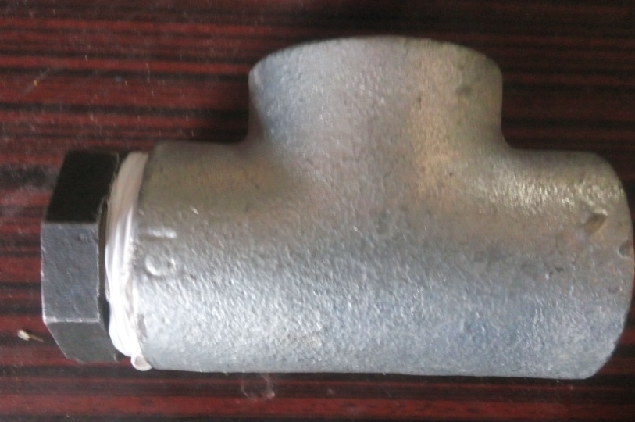

1. We connected 1-1/2’’ pipe nipple into the bushing and another side of this pipe nipple into 1-1/2’’ PVC Union.

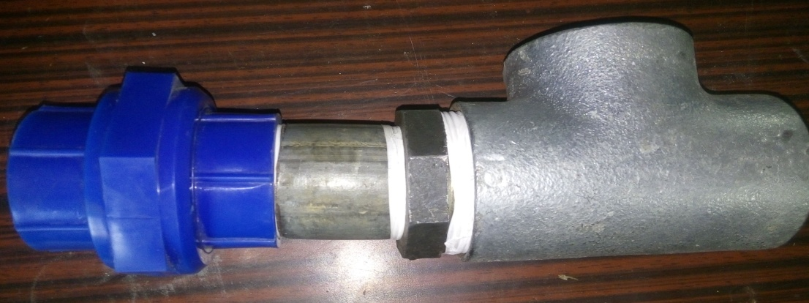

1. From the 1-1/2’’ pipe nipple we connected the 1-1/2’’ ball valve.

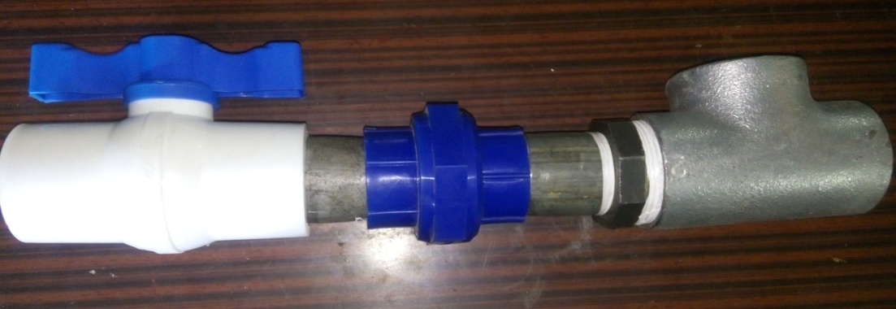

1. Then we connect the 1-1/2’’ pipe nozzle to this other side of ball valve.

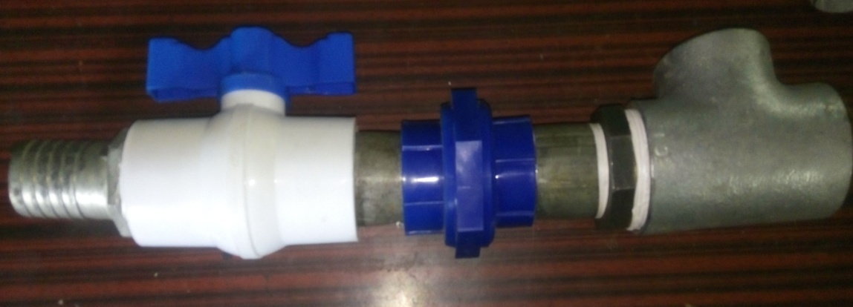

1. We connected 2’’ to 1’’ reducing bushing on the top of the tee.

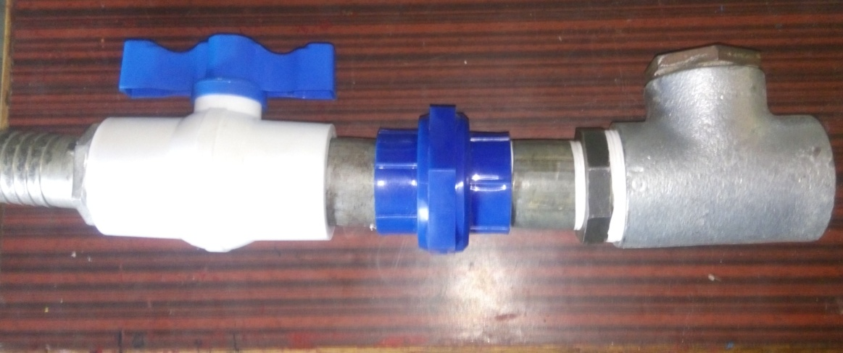

1. Then connected 1’’ pipe nipple to the 2 to 1’’ reducing bushing .

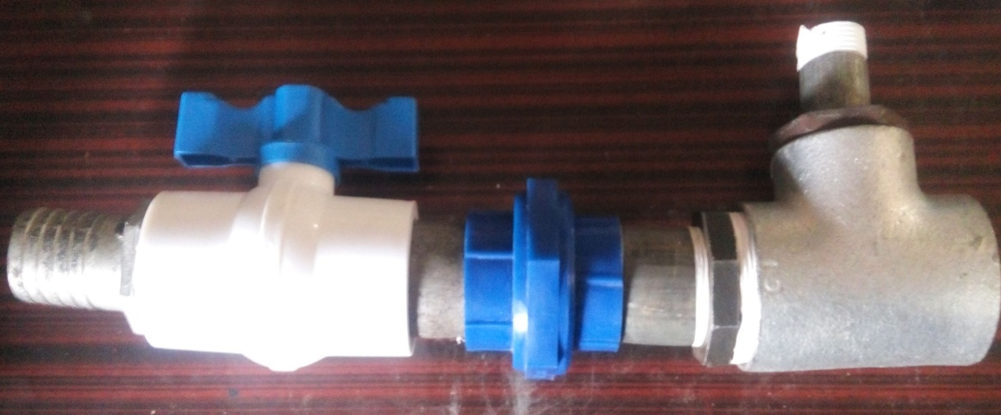

1. Then we connected the 1’’ check valve to the 1’’ elbow.

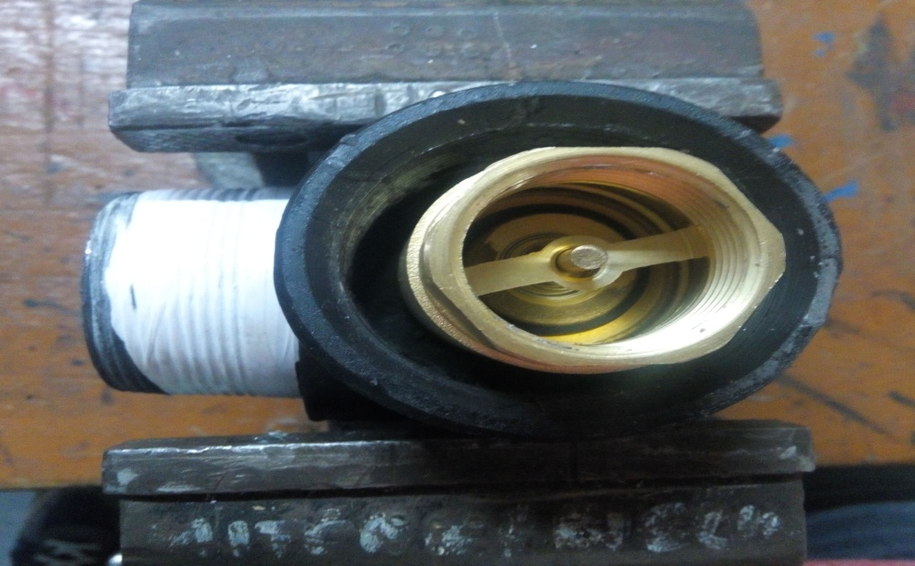

1. We connected 2’’ pipe nipple over the 2’’ female side of street elbow.

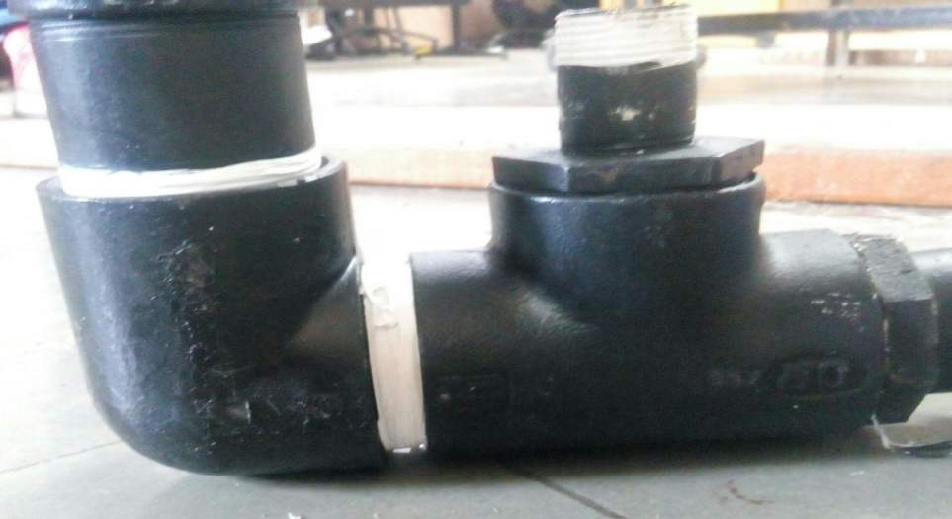

1. Then connected 2’’ Tee to the another side of the 2’’ pipe nipple.

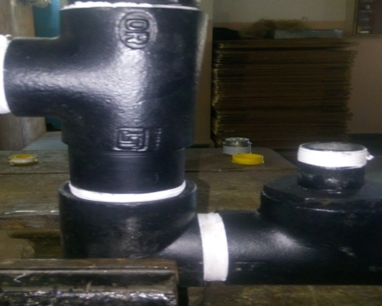

1. We connected 2’’to 3/4’’ bushing to the 2’’ Tee.

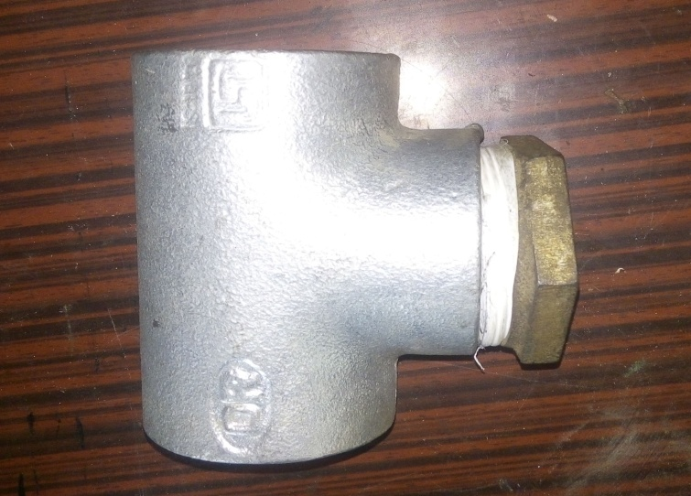

1. Then connected 3/4’’ pipe nipple to 2’’ to 3/4’’ bushing.

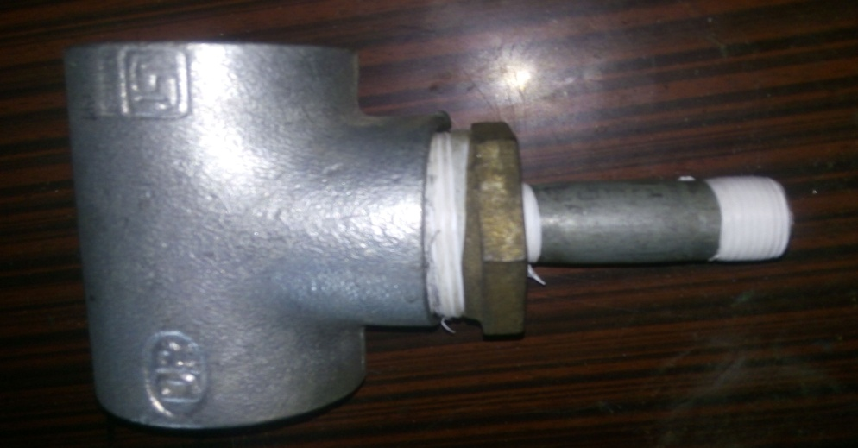

1. We connected another side of pipe nipple connected to the 3/4’’ tee.

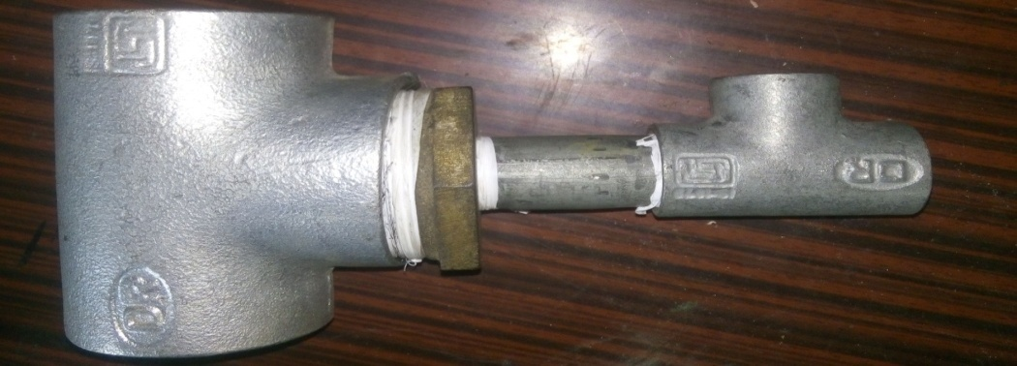

1. Then connected 3/4’’ to 1/4’’ reducing bushing and then connected 1/4’’ pipe nipple to the bushing and on another side of pipe we connected pressure gauge with the help of both side female threaded ball valve.

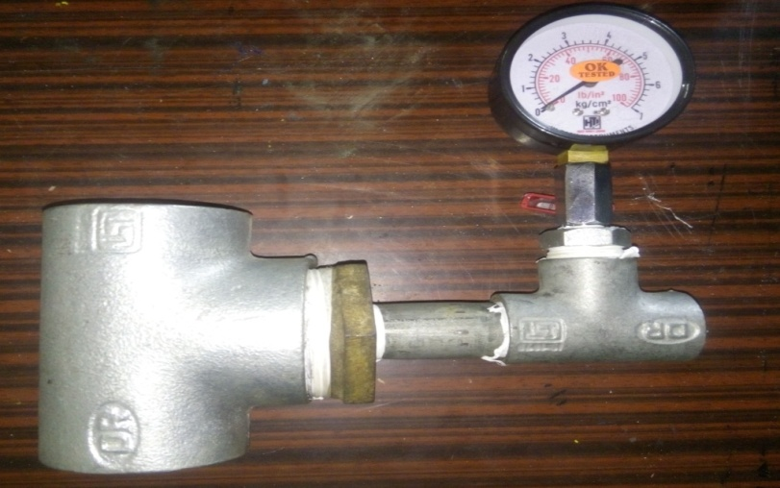

1. We connected 3/4’’ pipe nipple to the another side of the 3/4’’ tee.

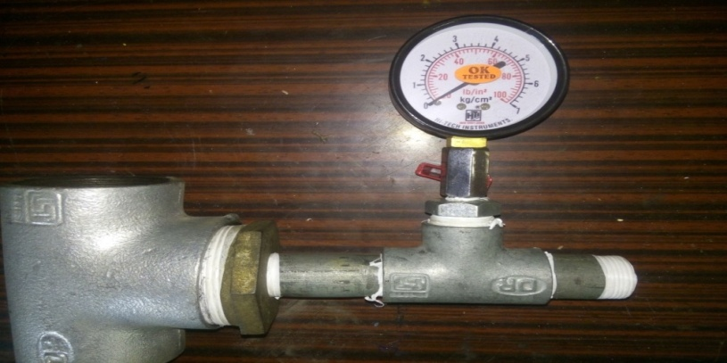

1. Then connected 3/4’’ ball valve to the other side of 3/4’’ pipe nipple.

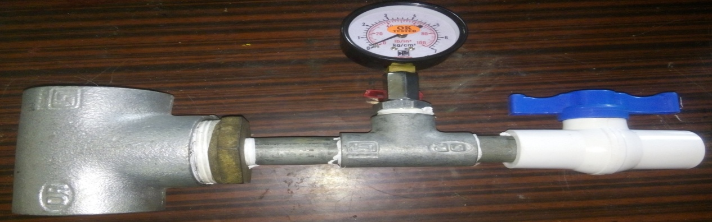

1. We connected 3/4’’ nipple to the ball valve.

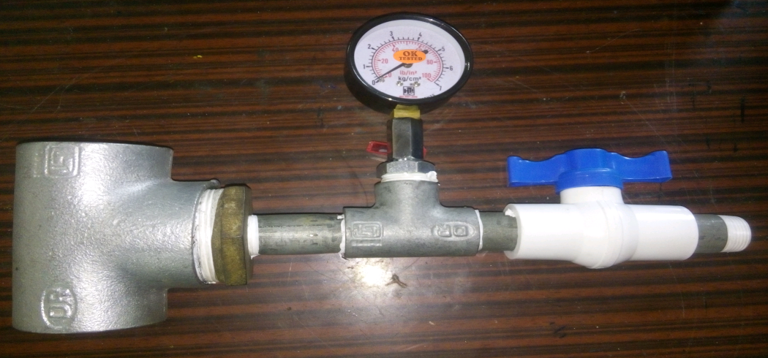

1. Then connected 3/4'’ union to the pipe nipple.

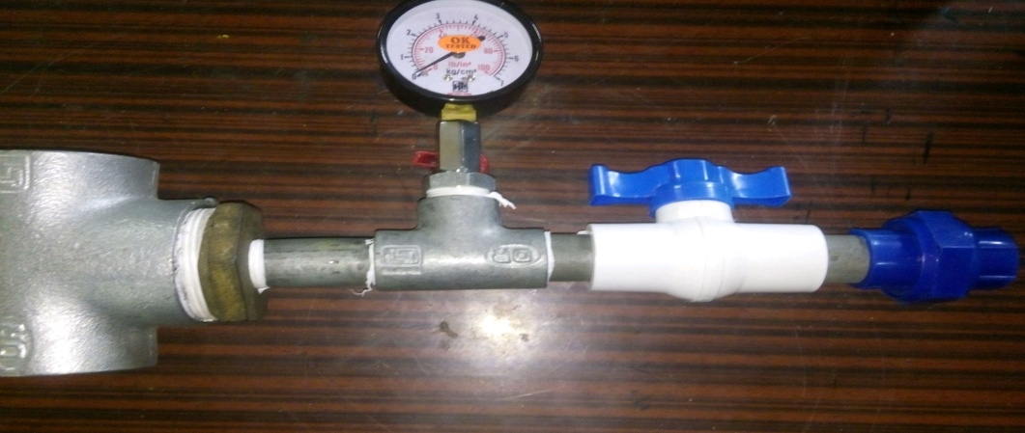

1. We connected 3/4'’ pipe nozzle to the union.

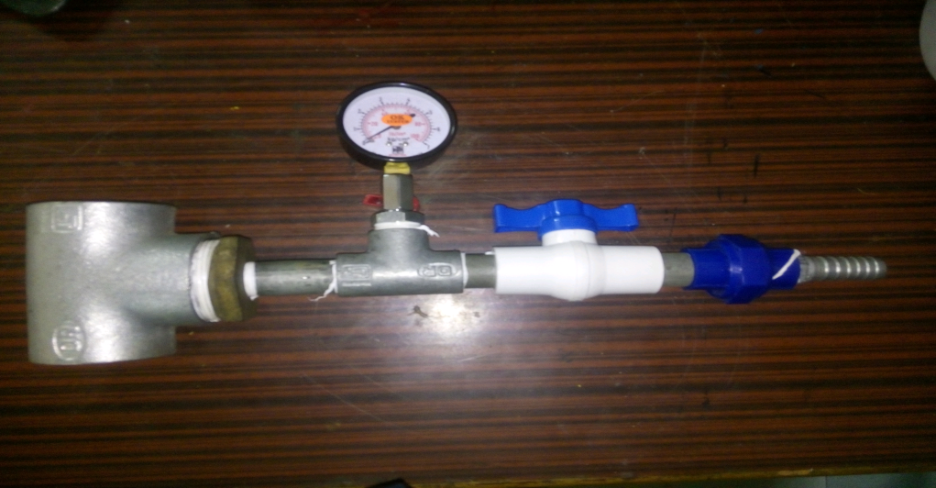

1. Then connected 2’’ nipple to the 2’’ Tee.

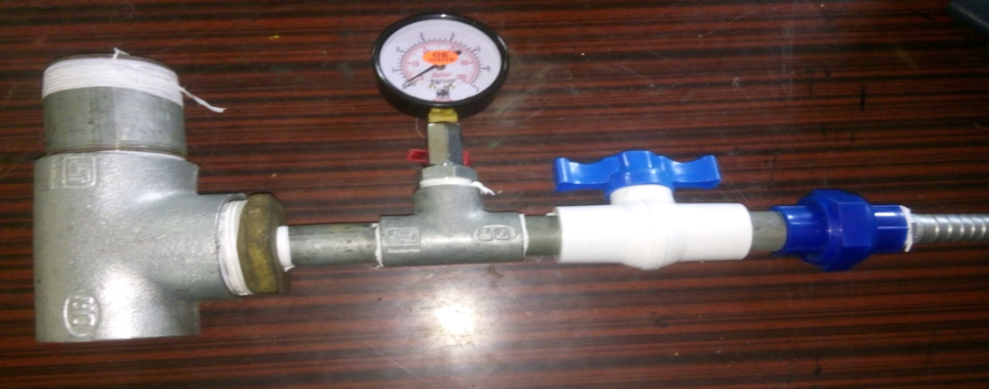

1. We connected 4’’to 2’’ PVC reducer through the female union to the nipple.

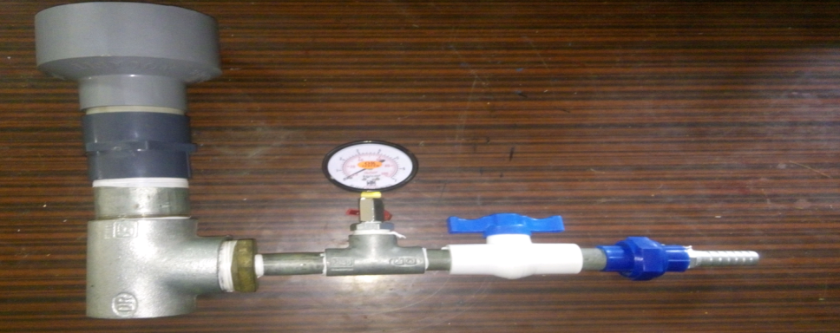

1. Then we connected Ram on the reducer and upper side of ram is connected to pipe cap.

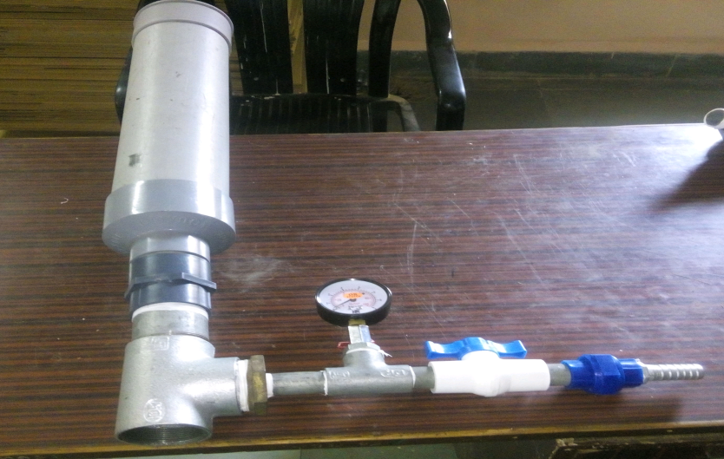

**5.3 Actual Setup of Hydraulic Ram Pump (Figure)**

**Fig.12:-Actual Setup of Hydraulic Ram Pump**

**5.4 Maintenance**

* Winterizing – pipelines must be drained prior to freeze up.
* Intake – keep the inlet clear of all debris and sand at all time. In-stream water level should be check periodically to insure adequate water supply is continuously being delivered to the pump.
* Drive system – the pipe delivery route should be visually inspected once a year for breakage or leakage.
* Pump – all studs, nuts, and bolts should be inspected regularly for defects and all appurtenances checked for leakage or cracks. The pump must be removed at the end of the watering season and reinstalled at the start of the following season. Follow the manufacturer’s suggested maintenance schedule.
* Delivery pipes – the pipe delivery route should be visually inspected once a year for breakage or leakage.
* Outlet and storage tank – check area adjacent to tanks for signs of erosion from overflow water.

**5.5 Troubleshooting**

1. **The waste valve does not work, but remain closed after repeated openings by hand.**

Check to see that there is enough weight on the bolt stem or swing plate of check valve. Check that the delivery valve is not blocked by debris, and is functioning properly. Check the waste valve seating on the wall plate, it should not leak when held closed and should move freely without interference from the inside walls of the pipe nipple.

**2. The waste valve works for a few strokes by itself and then stop.**

This usually indicates that there is air in the drive pipe. Check that the supply of water is sufficient and the drive pipe mouth is filled by at least twice of the supply head with water. By holding the valve closed for a few minuts the air bubbles will rise to the top of the drive pipes. If there is sufficient water hold thr valve open for several seconds will help drain any trapped air. Check that all the pipe joints are free fron leakage.

**3. Pump is operating, but there is no water being delivered**

Check to see that the delivery gate valve is open, there is no obstruction in the delivery pipe including air blockage, and the delivery valve is holding the pressure, so that no water is leaking out below the air chamber. (This last condition can be tested by filling the delivery pipe with water and checking to see that the water level does not fall). Check the valve for wear and proper seating.

**4. The impulse valve stays open.**

This indicates that there is not sufficient water in the drive pipe, or the wase valve weight is excessively heavy, oe the delivery valve is not functioning.

**5. For minimizing head losses.**

The use of elbows, tees, and reducers must be minimized in order to reduce head losses. Especially at the exit of the pump, elbows and tees are creating head losses that reduce a lot the flow of water in the storage tank. Indeed, at the exit of the pumps, the flow is not yet constant: the water travels by waves that flow at high velocity. The head loss at high velocity is greater than at low velocity. This is why is advised to avoid elbows and tees at the beginning of the delivery pipes.

**5.6 Mounting the Ram Pump**

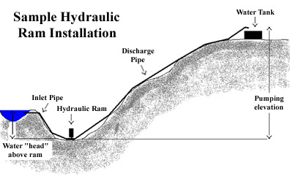

**Fig.13:- Installation of Ram Pump**

**Figure 1.**

This installation is the "normal" ram system where the inlet pipe is

less than the maximum length allowed. No stand pipe or open

tank is required.

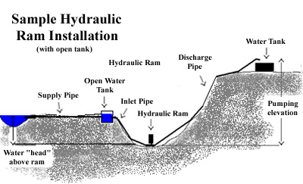 **Fig.14:- Mounting the Ram Pump(with open tank)**

**Figure 2.**

This installation is one option used where the inlet pipe is longer than the maximum length allowed. The open water tank is required to allow dissipation of the water hammer shock wave.

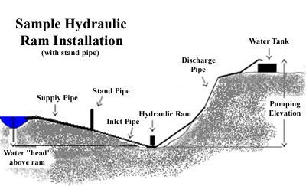 **Fig.15:- Mounting the Ram Pump(with stand pipe)**

**Figure 3.**

This installation is another option used where the inlet pipe is

longer than the maximum length allowed. The stand pipe

(open to atmosphere at the top) is required to allow

dissipation of the water hammer shock wave.

**5.7 Bill of Material :**

|  |  |  |  |  |
| --- | --- | --- | --- | --- |
| **Sr. No.** | **Material** | **Quantity** | **Price** | **Dimensins (in m.)** |
| 1 | 4''*18'' schduled 160 PVC pipe | 1 | 75 | 0.1016*0.4572 |
| 2 | 4''PVC pipecap (Rounded high pressure,not waste grade) | 1 | 60 | 0.1016 |
| 3 | 4'' to 2'' pipe PVC pipe reducer | 1 | 120 | 0.1016*0.0508 |
| 4 | 2'' PVC FTA |  | 60 | 0.0508 |
| 5 | 2'' 'T' female | 2 | 260 | 0.0508 |
| 6 | 2'' close nipple | 2 | 108 | 0.0508 |
| 7 | 1'' waste valve | 1 | 550 | 0.0254 |
| 8 | 1'' check valve | 1 | 550 | 0.0254 |
| 9 | 2'' street elbow | 1 | 740 | 0.0508 |
| 10 | 1'' street elbow | 1 | 160 | 0.0254 |
| 11 | 2''*1'' bushing | 1 | 160 | 0.0508*0.0254 |
| 12 | 1'' close nipple | 1 | 20 | 0.0254 |
| 13 | 2''*3/4'' bushing | 1 | 75 | 0.0508*0.01905 |
| 14 | 1.5''PVC union with thread | 1 | 90 | 0.0381 |
| 15 | 1.5'' ball valve | 1 | 200 | 0.0381 |
| 16 | 3/4'' metal tee (female) | 1 | 40 | 0.01905 |
| 17 | 3/4''ball valve(with threads) | 1 | 80 | 0.01905 |
| 18 | 3/4'' PVC Union (with threads) | 1 | 40 | 0.01905 |
| 19 | 1/4'' pipe cock | 1 | 30 | 0.00635 |
| 20 | 100psi pressure gauge | 1 | 330 |  |
| 21 | 1/4'' nipple | 1 | 30 | 0.00635 |
| 22 | 3/4'' close nipple | 2 | 20 | 0.01905 |
| 23 | 3/4''*2'' nipple | 1 | 30 | 0.01905*0.0508 |
| 24 | 3/4'' nozzle | 1 | 30 | 0.01905 |
| 25 | 1.5''*3'' close nipple | 2 | 90 | 0.0508 |
| 26 | 1.5'' nozzle | 1 | 60 | 0.0508 |
| 27 | 3/4''*1/4'' bushing | 1 | 40 | 0.01905*0.00635 |
| 28 | 3/4'' drive pipe | 1 | 625 | 0.00635*0.025*25 |
| 29 | 2'' pipe | 1 | 960 | 0.508 |
| 30 | Fiberglass resin and hardener | 1 | 220 |  |
| 31 | 100 grit sandpaper | 1 | 20 |  |
| 32 | PVC primer and cement | 1 | 90 |  |
| 33 | Black paint (spray and liquid rust) | 1 | 200 |  |
| 34 | Teflon thread pipe | 4 | 80 |  |
| 35 | 3/4'' hose clip | 1 | 8 |  |
| 36 | 1.5'' hose clip | 2 | 20 |  |
| 37 | M-ceil | 2 | 60 |  |
| 38 | Wheel Barrow Inner Tube | 1 | 80 |  |
| 39 | Other |  |  |  |
|  | **Total** |  | **6411** |  |

**6. DESIGN AND CALCULATIONS**

**6.1 Design Factors:**

* The difference in height between the water source and the pump site (called vertical fall).
* The difference in height between the pump site and the point of storage or use (lift).
* The quantity (Q) of flow available from the source.
* The quantity of water required.
* The length of pipe from the source to the pump site (called the drive pipe).
* The length of pipe from the pump to the storage site (called the delivery pipe).

**Nomenclature:-**

n= speed of revolution of pump

L= length of drive pipe

R = pipe radius

As= area of drive pipe

l = length of delivery pipe

r = delivery pipe radius

Ad= area of delivery pipe

Hd=delivery head

Hs= supply head

Qs=supply rate

Qd = delivery rate

Qw= rate of water through waste valve.

Vt = velocity of fluid flow in T-junction

At=area of T-section

Vs=supply velocity

Vd= velocity through deliver pipe

Dwv= dia. Of waste valve

Awv=area of waste valve

Ds = diameter of supply pipe

**6.2 Design Considerations**

**6.2.1 drive pipe length**

Empirical relations to determine the drive pipe

L = 150 < L/D < 1000 (calvert)

* According to relationship between length and diameter of drive pipe:-

$$\frac{length of drive pipe}{diameter of drive pipe} = 300$$

$$\frac{L}{D} = 300$$

$$L= 300× 0.0381$$

$$L= 11.43≈ 12 meter$$

* According to relation between length of drive pipe and supply head:-

$$\frac{length of drive pipe}{supply head}= 4$$

$$length of drive pipe=4×3$$

L = 12 meter

* Range of drive pipe length for various pipe diameters:-

$$1\frac{1}{2}''=38.1mm$$

Length of drive pipe is minimum 6 meter and maximum 40 meter.

* According to relation between diameter of supply pipe and diameter of delivery pipe:-

$$\frac{supply pipe diameter}{delivery pipe diameter}=1.5$$

$$\frac{0.0381}{1.5}=0.0254 meter$$

= 1’’

(But, according to table 5*(Expected water output will be approximately 1/8 of the input flow,but will vary with installation fall (F) and elevation lift (E) as noted above. This chart is based on 5 feet of lift (E) per* *1 foot of fall (F).) ( in appendix)*

* According to relation between volume of pressure vessel and delivery pipe:-

$$\frac{volume of pressure vessel}{volume of delivery pipe}=2$$

$$volume of pressure vessel=2×\frac{π}{4}d^{2}×l$$

$v=$ $2×\frac{π}{4}{(0.0190)}^{2}×25$

$v$ $= 14.17×{10}^{-3}{ m}^{3}$

$$v= 14 litre$$

* Volume of pressure vessel $=$ $area×length$

$$v=\frac{π}{4}({0.1016}^{2})×0.4572$$

$$v=3.70668×{10}^{-3}{ m}^{3}$$

$$v= 4 litre$$

**6.3 Calculations:**

1. The volumetric discharge from the drive pipe is given by:-

$Qs=$

B. The Velocity of Fluid Flow in the Supply Pipe is given by:-

$$V_{S}=\frac{Q}{A_{s}}$$

$$Vs=\frac{Qs}{\frac{π}{4}{0.0381}^{2}}$$

$$Vs= m/s$$

C. The velocity of fluid flow in the delivery pipe is given by:-

$$V_{d = \frac{Q}{A_{d}}}$$

$$V_{d}=\frac{Qd}{\frac{π}{4}{0.0190}^{2}}$$

$V_{d}$ = m/s

D. Discharge through delivery pipe is given by:-

$$Q_{d= }A_{d}×V_{d}$$

$$=\frac{π}{4}×{0.0190}^{2}×$$

$$Q_{d}= m^{3}/s$$

E. Discharge through waste valve is given by:-

$Q_{w}$ = $Q_{S}$- $Q_{d}$

$$Q_{w}= m^{3}/s$$

F. Velocity of fluid flow in T-junction is given by:-

$V_{t}$ = $\frac{Qw}{At}$

$$V_{t}=\frac{Qw}{\frac{π}{4}×{0.0508}^{2}}$$

$$V_{t}= m/s$$

G. Losses

* Head losses in Supply pipe

1. Major loss due to friction in supply pipe is given by Darcy’s – Weisbach equation as,

$$h_{f}=\frac{4fl{V_{s}}^{2}}{2.gd}$$

$$h_{f}=f.\frac{L}{d}.\frac{V^{2}}{2g}$$

Where f = 0.03

* Minor head losses in supply pipe:-

1. Head loss at inlet :-

$H_{inlet}$ = $K× \frac{{Vs}^{2}}{H3 2g}$

1. Head loss due to pipe fittings (ball valve):-
$$H=K_{b}×\frac{{V_{s}}^{2}}{2g}$$

2. Head loss due to pipe fittings (coupling):-
$$H=K_{c}×\frac{{V_{s}}^{2}}{2g}$$

3. Head Loss Due to Sudden Enlargement *(*T SECTION):-

H $=\frac{{(Vs-Vt)}^{2}}{2g}$

1. Head loss due to sudden contraction (T-section / elbow)

H = $K×\frac{{V_{t}}^{2}}{2g}$

1. Head loss due to check valve:-
$$H=K×\frac{{V_{t}}^{2}}{2g}$$

2. Head Loss Due to Sudden Enlargement *(*elbow - t section):-

H $=\frac{{\left(Vs-Vt\right)}^{2}}{2g}$

* Head losses in delivery pipe

1. Major loss due to friction in delivery pipe is given by Darcy’s – Weisbach equation as,

$$h_{f}=\frac{4fl{V_{d}}^{2}}{2.gd}$$

$$h_{f}=f.\frac{L}{d}.\frac{V^{2}}{2g}$$

Where f = 0.03

* Minor head losses in delivery pipe:-

1. Head loss due to sudden contraction:-

H = $K×\frac{{V_{d}}^{2}}{2g}$

1. Head loss due to pipe fittings (T-section):-

H = $K×\frac{{V_{d}}^{2}}{2g}$

1. Head loss due to pipe fittings (ball valve):-
$$H=K_{b}×\frac{{V_{d}}^{2}}{2g}$$

2. Head loss due to pipe fittings (coupling):-
$$H=K_{c}×\frac{{V_{d}}^{2}}{2g}$$

3. Head loss at outlet :-

H = $\frac{{V_{d}}^{2}}{2g}$

1. Coefficient of friction is given by:-

F = $\frac{ 0.079}{({Re}^{1/4})}$

1. Re (Reynolds number) can be determined by:-

Re = $\frac{Vs×Vd}{10^-6}$

$$Re= m/s$$

1. Water acceleration in the driven pipe, this acceleration is given by*:-*

$$=H-f\frac{L}{D_{S}}×\frac{{V_{s}}^{2}}{2g}-\sum{headloss}$$

$$= m^{2}/s$$

1. Drag force given by equation:-

$$F_{d}=C_{d}×A_{t}×ρ×\frac{Vt}{2g}$$

$F_{d}= × \frac{π}{4}$ $×{0.0508}^{2}×1000×\frac{}{2×9.81}$

$$F_{d}= N$$

1. The force that accelerates the fluid is given by:-

F = $m×a$

F $=ρ×As×L×\frac{dv}{dt}$

$$=1000×\frac{π}{4}{0.0381}^{2}×12×$$

$$F= N$$

1. The pressure at waste valve is obtained by:-

P= $\frac{F}{At}$

$$P=\frac{}{\frac{π}{4}{0.0508}^{2}}$$

$$P= N/m^{2}$$

1. The power required can k calculated using this expression:-

P = $ρ×g×h×Qs$

$$P= KW$$

Where, h = Hd-Hs

1. Theefficiency of the hydram is given by:-

Efficiency = $\frac{Q_{d}×H}{(Qd+Qw)×Hs}$ $× 100$

1. D’Aubuisson’s efficiency:-

D’Aubuisson’s efficiency $= \frac{q×effective head}{Q×h}$

1. Rankine efficiency:-

Rankine efficiency = $\frac{q×(effective load-h)}{(Q-q)h}$

**7. OBSERVATIONS AND RESULTS:**

**7.1 Observation table**

Supply head = m

Delivery head = m

Supply of water = m

|  |  |
| --- | --- |
| Parameters | Value |
| Drive pipe diameter | Mm |
| Drive pipe length | Mm |
| Speed of diaphragm | Beats/ min. |
| Flow discharge in drive pipe | Lit./sec |
| Total head losses in system | M |
| Force on waste valve | N |
| Pressure at waste valve | Kn/m^2 |
| Power developed by hydram |  |
| Hydraulic pump efficiency |  |

**7.2 Results**

|  |  |  |  |
| --- | --- | --- | --- |
| Supply Head(m) | Delivery Head(m) | Supply Discharge(lit/min.) | Delivery Discharge(lit/min.) |
| **1.5** | **3.00** | **18** | **8** |
| **1.5** | **5.5** | **18** | **5** |
| **2** | **5.5** | **19** | **6** |
| **2** | **9** | **19** | **1** |
| **2.5** | **6** | **20** | **9** |
| **2.5** | **9.5** | **20** | **2.4** |
| **3** | **7** | **20** | **6** |
| **3** | **10** | **20** | **3** |

**7.3 Efficiency**

**8. CONCLUSION**

* The hydraulic ram pump prototype of good quality and high performance was successfully fabricated and tested.
* The ram developed is low cost of high performance comparable with commercial models.
* A proven and effective methodology to identify suitable sites for hydraulic ram use was evolved and tested.
* A locally made was successfully developed and tested. It is recommended that ministry of water and agriculture department to establish small scale water supply schemes using pumps to utilize the this pump so that it would greatly solve water problems for agricultural as well as domestic purpose.

**9. APPENDIX**

**Conversion factors:-**

1. 1’’ (1 inch) = 2.54 cm
2. 1 psi (pound/ square inch) = 6.895 Kpa or 0.06895 bar
3. 1 gallon per minute = 3.78 liter per minute
4. PR 160 PVC pipe is rated 160 psi pressure
5. 1’ (1 feet) = 12’’ (12 inch)

**APPENDIX 1**

**Table 1. Range of Drive Pipe Lengths**

**For Various Pipe Diameters**

|  |  |  |
| --- | --- | --- |
| Drive pipe size (mm) | Length (meters) | |
| Minimum | Maximum |
| 13 | 2 | 13 |
| 20 | 3 | 20 |
| 25 | 4 | 25 |
| 30 | 4.5 | 30 |
| 40 | 6 | 40 |
| 50 | 7.5 | 50 |
| 80 | 12 | 80 |
| 100 | 15 | 100 |

**APPENDIX 2**

**Table 2. Drive Pipe Diameters by**

**Hydram Manufacturer's Size Number**

|  |  |  |  |  |  |  |  |
| --- | --- | --- | --- | --- | --- | --- | --- |
| Hydram size | 1 | 2 | 3 | 3.5 | 4 | 5 | 6 |
| Pipe size (mm) | 32 | 38 | 51 | 63.5 | 76 | 101 | 127 |

**APPENDIX 3**

**Table 3. Hydram Capacity by Manufacturer's Size**

|  |  |  |  |  |  |  |  |  |  |
| --- | --- | --- | --- | --- | --- | --- | --- | --- | --- |
|  | Size of hydram | | | | | | | | |
| 1 | 2 | 3 | 3.5 | 4 | 5X | 6X | 5Y | 6Y |
| Volume of drive pipe needed (litres/min.) | 7-16 | 12-25 | 27-55 | 45-96 | 68-137 | 136-270 | 180-410 | 136-270 | 180-410 |
| Maximum Lift (m) | 150 | 150 | 120 | 120 | 120 | 105 | 105 | 105 |  |

**APPENDIX 4**

**Table 4. Sizing the Delivery Pipe**

|  |  |
| --- | --- |
| Delivery pipe size(mm) | Flow(liters/min.) |
| 30 | 6-36 |
| 40 | 37-40 |
| 50 | 61-90 |
| 80 | 91-234 |
| 100 | 235-360 |

**APPENDIX 5**

**Table5:- Typical Hydraulic Ram specifications**

|  |  |  |  |  |  |
| --- | --- | --- | --- | --- | --- |
| Drive pipe diameter(inches) | Delivery pipe diameter(inches) | At Minimum Inflow | | At maximum Inflow | |
| Pump Inflow(gallons per minute) | Expected output(gallons per minute) | Pump Inflow(gallons per minute) | Expected output(gallons per minute) |
| 3/4 | 1/2 | ¾ | 1/10 | 2 | ¼ |
| 1 | 1/2 | 1-1/4 | 1/5 | 6 | ¾ |
| 1-1/4 | 1/2 | 2 | ¼ | 10 | 1-1/5 |
| 1-1/2 | 3/4 | 2-1/2 | 3/10 | 15 | 1-3/4 |
| 2 | 1 | 3 | 3/8 | 33 | 4 |
| 2-1/2 | 1-1/4 | 12 | 1-1/2 | 45 | 5-2/5 |
| 3 | 1-1/2 | 20 | 2-1/2 | 75 | 9 |
| 4 | 2 | 30 | 3-5/8 | 150 | 18 |
| 6 | 3 | 75 | 9 | 400 | 48 |
| 8 | 4 | 400 | 48 | 800 | 96 |

**APPENDIX 6**

**Table 5 :- Values of coefficient of K**

The value of Cc depends on the ratio A2/A1.

$$K={\left[(\frac{1}{C_{C}})-1\right]}^{2}$$

|  |  |  |  |  |  |  |
| --- | --- | --- | --- | --- | --- | --- |
| A2/A1 | 0 | 0.04 | 0.16 | 0.36 | 0.64 | 1.0 |
| K | 0.5 | 0.45 | 0.38 | 0.28 | 0.14 | 0 |

**APPENDIX 7**

**Table 6 :- Reynolds No.**

|  |  |
| --- | --- |
| Laminar flow | Re < 2000 |
| Transitional Flow | 2000 < Re < 4000 |
| Turbulent Flow | Re > 4000 |

**Table 7 :- Darcy’s frictional factor for a commercial pipe at complete turbulence**

|  |  |  |  |  |  |  |  |  |  |
| --- | --- | --- | --- | --- | --- | --- | --- | --- | --- |
| Pipe size | 1’’ | 1.5’’ | 2’’ | 3’’ | 4’’ | 6’’ | 8’’-10’’ | 12-16’’ | 18’’-24’’ |
| Darcy’s friction factor | 0.023 | 0.021 | 0.019 | 0.018 | 0.017 | 0.015 | 0.014 | 0.013 | 0.012 |

10. **REFERENCES**

1. S. Sheikh, C. C. Handa and A. P. Ninawe, “Design methodology for hydraulic ram pump (hydram)”, International journal of mechanical engineering and robotic research, vol. 2, no. 4, **(2013)**, pp. 170-175.
2. S. N. Mohammed, “Design and Construction of a Hydraulic Ram Pump”, Leonardo Electronic Journal of Practices and Technologies, No. 11, **(2007)**, pp. 59-70.
3. H. W. Iversen, “An Analysis of the Hydraulic Ram”, Journal of Fluids Engineering, vol. 97, no. 2, **(2010)**, pp. 191-196.
4. R.S.Khurmi, “Hydraulic, Fluid Mechanics and hydraulic machines”(2014),

pp. 674-680.

1. P. Balchandran “Engineering Fluid Mechanics”(2012), pp-796-798.
2. Dr. A.K. Jain “Fluid Mechanics (including hydraulic machines), (2014)

pp-988-995.